**ORFF-SCHULWERK MUSICAL APPROACH**

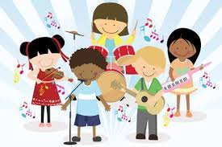

Music, speech and dance are means of self-expression. Every person, whether child, young, old or disabled, has the ability to express himself artistically. The foundations of the “Orff Schulwerk” education system, developed by Carl Orff and Gunild Keetman based on this principle, were laid in the Günther school established in Munich in the 1930s. The book series has been published. After the publication of these books, “Orff Schulwerk” became one of the emerging music pedagogy systems of the 20th century.

The desire that underlies Orff and Keetman's ideas and work; is that all people feel the sense of music, speech, dance and the rhythm that emerges from the combination of these three, and in this way, the creative power within people is triggered. The products that will emerge as a result of this creation will contribute to the personality development of individuals as well as improve their social and communication skills. “Orff-Schulwerk” prepares an environment for people to reveal their already existing creative powers, is based on rhythm, movement and speech, allows people to make music, dance and improvise as they feel, by combining all artistic fields for people to learn, explore, It is an educational approach that offers an environment of experimentation and creation.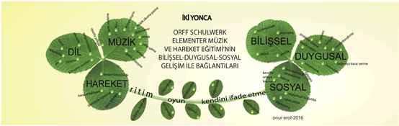

In this educational approach, unlike traditional instrument or dance teaching, people of all levels and abilities experience an interactive process of creativity and self-expression within a group. Learning through group work is much easier for a human being, who is basically a social being.

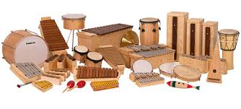

The most important thing that is indispensable in every stage of Orff's work, from the preparation of the body with movements to the use of speech, from the rhythm of speech to the transformation of these rhythms into music, and to the presentation (sharing) of all these tools as a result of a series of creative processes, is the "game". There are countless music and movement games that can be used in the studies, and when and how these games will be used during the lesson is determined by the Orff Educator according to the objectives of the course that day. Since the emotional right part of the brain and the cognitive left part are used together in all these course processes, the learning process is also faster.The Orff approach is suitable for people of all ages. There are many examples of working with different age groups, from those with 18-month-old babies to those with the elderly in nursing homes.